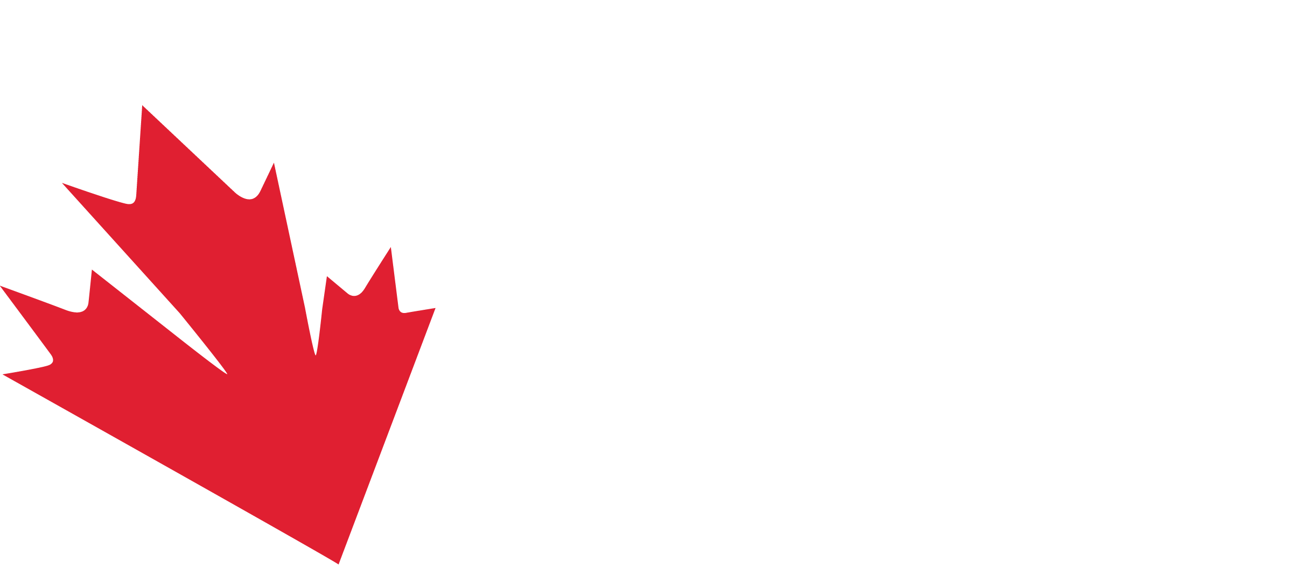
DUE BEFORE MARCH 27TH TO CANADACUP@DIVING.CA
FINAL ENTRY FORM
2024 CANADA CUP OF DIVING
MAY 2ND TO 5TH, 2024 | CALGARY, CANADA

COUNTRY: |  |  | 3-LETTER COUNTRY CODE:

ENTRY LIST
LAST NAME | FIRST NAME | M / F | 3M | 10M | 3M SYN | 10M SYN

OTHER DELEGATES (coach, manager, OFFICIAL, THERAPIST, ETC.)
LAST NAME | FIRST NAME | ROLE ON THE TEAM

President or General Secretary Signature
Federation Stamp
